INFOSYS CYBER THREAT ANALYTICS PLATFORM WITH INCIDENT VISUALIZATION SYSTEM
Final Project Report
Batch-1 Group 2
Submitted by
Pavani Mudigonda

TABLE OF CONTENTS
- Project Overview
- Problem Statement
- Project Objectives
- Project Scope
- Datasets Used
- Tools and Technologies
- Project Methodology
- Data Preparation and Cleaning
- Data Modeling
- Milestone 1 – Threat Classification and Severity Analytics
- Milestone 2 – Threat Classification and Geospatial Intelligence
- Milestone 3 – Temporal and Incident Response Analytics
- Milestone 4 – Security Risk Assessment and Predictive Intelligence
- Executive Intelligence Dashboard
- Dashboard Interactivity
- Key Project Insights
- Strategic Recommendations
- Limitations
- Future Scope
- Conclusion

1. PROJECT OVERVIEW
The project “Infosys Cyber Threat Analytics Platform with Incident Visualization System” focuses on analyzing cybersecurity incidents and presenting the results through interactive Power BI dashboards.
The main purpose of the project is to convert cybersecurity data into useful information that can help users understand:
- Cybersecurity incident patterns
- Threat categories
- Severity levels
- Geographical risk
- Incident response performance
- Operational vulnerabilities
- Security risk indicators
- Predicted risks
- Emerging risk areas
- Executive-level decision-support information
The project was developed progressively through four milestones.
The four milestones move from basic incident analysis to geographical analysis, temporal and response analysis, and finally security risk assessment, predictive intelligence and executive analytics.
The overall analytical flow is:
Incident Data → Classification → Geographical Analysis → Temporal & Response Analysis → Risk Assessment → Predictive Intelligence → Executive Decision Support

2. PROBLEM STATEMENT
Cybersecurity incidents can occur across different locations, departments, assets and threat categories.
Large volumes of incident data can make it difficult to identify important patterns and understand which areas require immediate attention.
The project therefore aims to develop an interactive cybersecurity analytics platform that can:
- Classify cybersecurity threats
- Analyze incident severity
- Understand geographical distribution
- Analyze incident trends over time
- Evaluate response and resolution performance
- Identify security vulnerabilities
- Assess risk across locations and operational units
- Identify high-risk areas
- Support predictive risk analysis
- Provide executive-level insights for decision-making
The final solution uses Power BI dashboards to present these insights in an interactive and understandable way.
3. PROJECT OBJECTIVES
The main objectives of the project are:
- To analyze cybersecurity incidents using structured datasets.
- To classify incidents based on threat categories and severity.
- To understand the geographical distribution of cybersecurity incidents.
- To analyze incident trends across different time periods.
- To evaluate incident response and resolution performance.
- To identify operational vulnerabilities and security weaknesses.
- To compare risk indicators across locations and operational units.
- To identify potential high-risk zones.
- To perform predictive threat and risk analysis.
- To identify emerging risk areas and incident trends.
- To create executive-level security dashboards.
- To provide decision-support information for security management.
4. PROJECT SCOPE
The project covers the following major areas:
Incident Analytics
Analysis of cybersecurity incidents based on:
- Threat category
- Severity
- Location
- Date and time
- Incident status
- Response information
Geospatial Intelligence
Analysis of:
- Incident concentration by location
- Risk by city/country
- High-risk locations
- Geographical threat patterns
Temporal Analytics
Analysis of:
- Hourly trends
- Daily trends
- Weekly trends
- Monthly trends
- Seasonal patterns
- Incident spikes and changes over time
Incident Response Analytics
Analysis of:
- Response time
- Resolution time
- Open and closed incidents
- Response performance
- Response pressure by location and operational unit
Security Risk Assessment
Analysis of:
- Threat exposure
- Operational vulnerability
- Critical risk zones
- Resource allocation gaps
- Security weaknesses
- Risk scorecards
Predictive Intelligence
Analysis of:
- Predicted threat risk
- Incident risk probability
- Predicted risk trends
- Emerging risk areas
- Potential high-risk zones
- Risk probability by category and risk level
Executive Analytics
A summarized dashboard containing:
- Overall risk score
- Critical risk indicators
- Predicted risk
- Resource allocation indicators
- Average response time
- Total incidents
- High-risk locations
- Emerging risk areas
- Operational risk indicators

5. DATASETS USED
The project uses cybersecurity-related datasets supplied for the project.
The main datasets used in the analysis include:
5.1 Security Incidents
This dataset contains information about cybersecurity incidents.
Important information includes:
- Incident information
- Threat category
- Severity
- Location
- Date/time
- Security risk indicators
- Other incident-related attributes
This dataset is mainly used for incident classification, severity analysis, risk analysis and trend analysis.
5.2 Incident Response
This dataset contains information related to the response and resolution of incidents.
Important information includes:
- Incident reference
- Response information
- Resolution time
- Response-related attributes
- Incident status
This dataset is mainly used for response and resolution analysis.
5.3 Asset Inventory
The Asset Inventory dataset contains information about assets and their security-related status.
It is used to understand:
- Asset information
- Patch status
- Security weaknesses
- Operational risk
5.4 Supporting Data
Additional supporting information such as location, weather/environmental information and date-related information was used where required by the milestone analysis.
Dataset Preparation
The datasets were prepared and transformed before being used for visualization and analysis.
6. TOOLS AND TECHNOLOGIES
Microsoft Power BI
Power BI was used as the main platform for:
- Data visualization
- Dashboard development
- Interactive reporting
- KPI creation
- Risk analysis
- Predictive visualization
- Executive reporting
Power Query
Power Query was used for:
- Data cleaning
- Data transformation
- Data type correction
- Removing unnecessary records
- Handling missing values
- Preparing datasets for analysis
DAX
DAX was used to create calculated measures and analytical indicators.
Examples include:
- Total Incidents
- Critical Incidents
- Average Response Time
- Threat Severity Index
- Operational Vulnerability Score
- Predicted Risk
- Risk Probability
- Other dashboard KPIs
Microsoft Excel
Excel was used for working with and preparing datasets before or during Power BI analysis.
7. PROJECT METHODOLOGY
The project was developed using the following process:
Step 1 – Data Collection
The required cybersecurity datasets were collected and prepared for analysis.
Step 2 – Data Cleaning
The data was cleaned using Power Query.
This included:
- Checking missing values
- Correcting data types
- Removing unnecessary data
- Standardizing fields
- Preparing columns for analysis
Step 3 – Data Modeling
The cleaned datasets were connected through appropriate relationships.
A structured data model was created so that different datasets could be analyzed together.
Step 4 – DAX Measures
DAX measures were created for important KPIs and risk indicators.
Step 5 – Dashboard Development
The dashboards were developed milestone by milestone.
Step 6 – Interactive Analysis
Slicers, filters, maps, tooltips and other interactive features were added.
Step 7 – Risk and Predictive Analysis
Risk indicators and predictive analysis were incorporated into the later milestones.
Step 8 – Executive Reporting
The final executive dashboard summarized the most important security insights.

8. DATA PREPARATION AND CLEANING
Before creating the dashboards, the datasets were prepared for analysis.
The major data preparation activities included:
- Checking the structure of the datasets
- Removing unnecessary columns
- Handling missing or incomplete values
- Correcting incorrect data types
- Standardizing categorical values
- Preparing date and time fields
- Preparing location information
- Creating calculated fields where required
- Connecting related datasets
Power Query was used as the primary data preparation tool.
This step was important because clean and consistent data is required for reliable dashboard analysis.
9. DATA MODELING
The datasets were connected using relationships based on common fields.
The data model was designed to support analysis across:
- Incidents
- Responses
- Assets
- Locations
- Dates
- Other supporting information
The model allows the dashboard visuals and measures to respond correctly when users apply filters.
The data model also supports the analysis performed across the four milestones.

10. MILESTONE 1 – THREAT CLASSIFICATION AND SEVERITY ANALYTICS
10.1 Objective
The first milestone focuses on understanding the basic cybersecurity incident structure.
The main purpose is to classify incidents and analyze their severity, response indicators and geographical distribution.
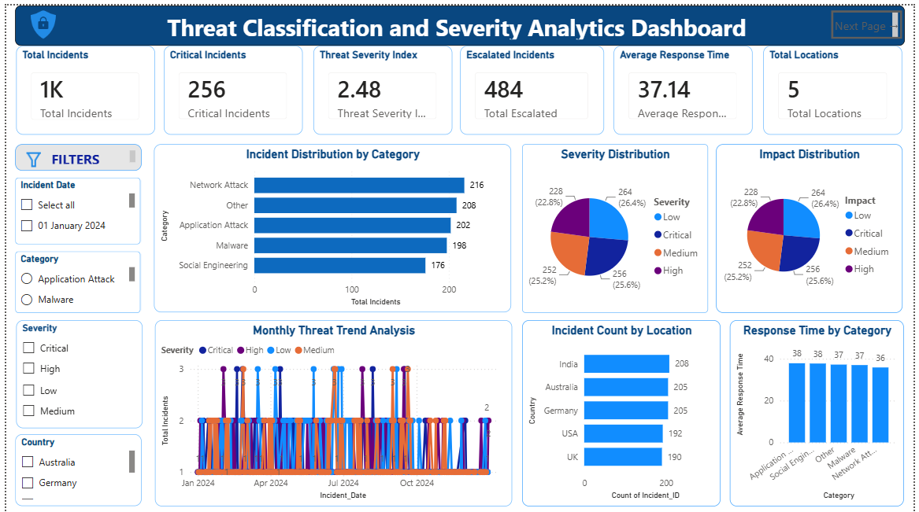
10.2 KPI Analysis
The dashboard contains important KPI cards to provide a quick overview of the incident data.
Examples include:
- Total Incidents
- Critical Incidents
- Threat Severity Index
- Average Response Time
- Total Locations
- Escalated Incidents
These KPIs provide an immediate summary before users explore the detailed visuals.
10.3 Threat Classification
The dashboard analyzes incidents based on their threat category.
This helps identify the types of cybersecurity threats appearing in the dataset.
Examples of threat categories include different types of attacks such as:
- Network attacks
- Malware
- Application attacks
- Social engineering
- Other threat categories
10.4 Severity Analysis
Incident severity is analyzed using different levels such as:
- Low
- Medium
- High
- Critical
The severity distribution helps users understand the overall seriousness of the incidents.
10.5 Incident Trend
The incident trend visual shows how incidents change over time.
This helps identify periods with:
- Higher incident counts
- Lower incident counts
- Changes in incident activity
- Possible spikes
10.6 Response Analysis
Average response time is analyzed to understand how quickly incidents are handled.
This provides an operational view of incident management performance.
10.7 Geographical Analysis
Incident locations are analyzed to understand the geographical distribution of threats.
This helps identify locations with comparatively higher incident activity.
10.8 Slicers
The milestone includes interactive slicers such as:
- Date
- Category
- Severity
- City/Country
These slicers allow users to analyze selected parts of the data.
10.9 Milestone 1 Outcome
Milestone 1 established the basic analytical foundation of the project.
It helped transform raw cybersecurity incident data into understandable incident, severity, response and location insights.
11. MILESTONE 2 – THREAT CLASSIFICATION AND GEOSPATIAL INTELLIGENCE
11.1 Objective
Milestone 2 focuses mainly on geographical and threat intelligence.
The objective is to understand where threats are concentrated and identify locations that may require additional attention.
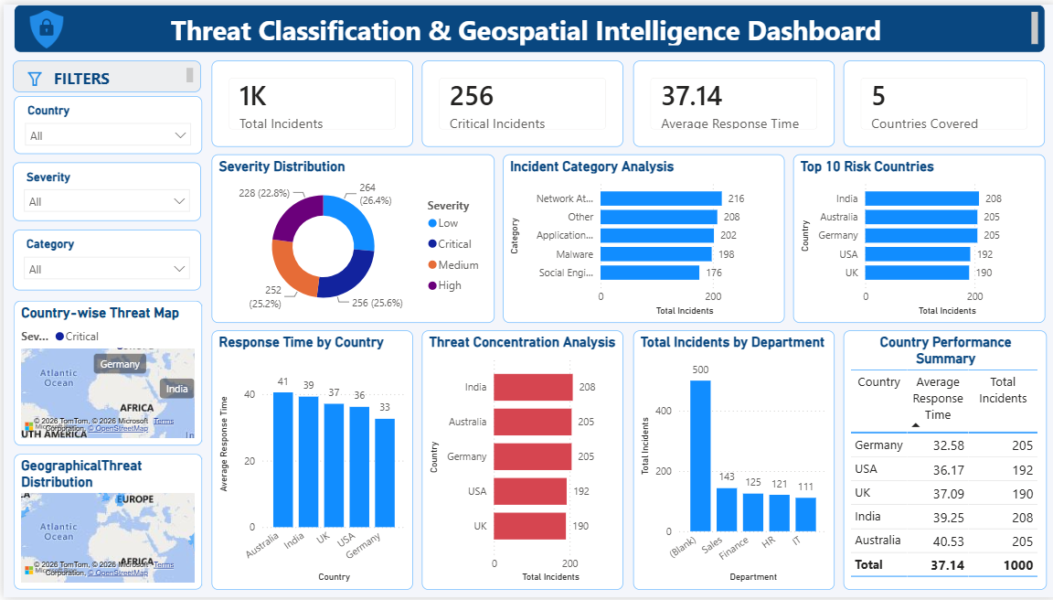

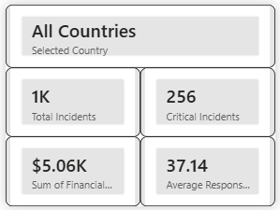
Figure: Tooltip
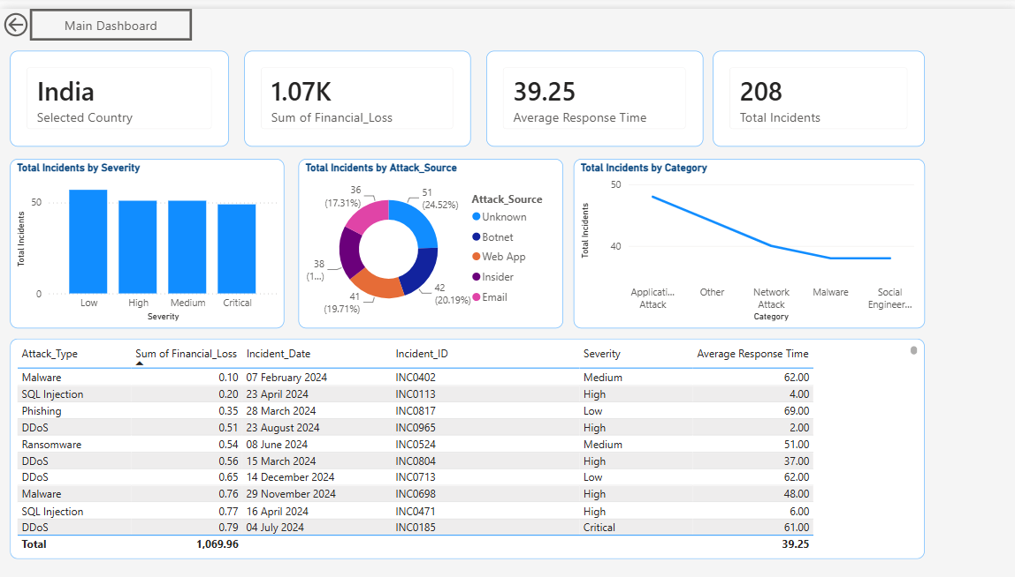
Figure: Country Details
11.2 Geographical Analysis
Maps were used to visualize incident and risk information geographically.
The geographical visuals allow users to identify differences between locations.
11.3 Bubble Map
The bubble map provides a geographical representation of incident-related information.
The size of the bubbles helps users understand the relative concentration of incidents or risk.
11.4 Filled Map
The filled map provides another geographical view.
Different areas can be compared based on the selected risk or incident measure.
This makes it easier to identify locations with relatively higher activity.
11.5 Top Risk Cities
A Top 10 risk-city analysis was included to identify locations with comparatively higher risk.
This helps security teams prioritize locations requiring additional monitoring.
11.6 Response Time by City
Response time was compared across cities.
This helps identify locations where incident response may take longer.
Higher response time can indicate a need to examine response processes or resource availability.
11.7 Threat Concentration
The dashboard analyzes where particular threat categories are concentrated.
This helps users understand whether certain locations are more associated with particular threat types.
11.8 Context Analysis
Environmental or supporting context was incorporated where required.
This helps users explore whether external conditions are associated with changes in incident activity.
11.9 Drill-through
Drill-through functionality allows users to move from a high-level view to a more detailed view for a selected location or category.
This makes the dashboard more interactive.
11.10 Tooltips
Tooltips provide additional information when users hover over visual elements.
This allows more information to be provided without making the dashboard visually crowded.
11.11 Dynamic Title
Dynamic titles help the dashboard title change based on selected filters.
This makes the current analysis context clear to the user.
11.12 Slicers
The dashboard uses filters such as:
- City/Location
- Severity
- Category
These allow users to focus on specific geographical or threat-related information.
11.13 Milestone 2 Outcome
Milestone 2 improved the project by adding geographical intelligence.
It helps users understand:
Where are incidents occurring?
Which locations have higher risk?
Where is response taking longer?
Which threats are concentrated in particular locations?

12. MILESTONE 3 – TEMPORAL AND INCIDENT RESPONSE ANALYTICS
12.1 Objective
Milestone 3 focuses on understanding incident behavior over time and evaluating incident response performance.
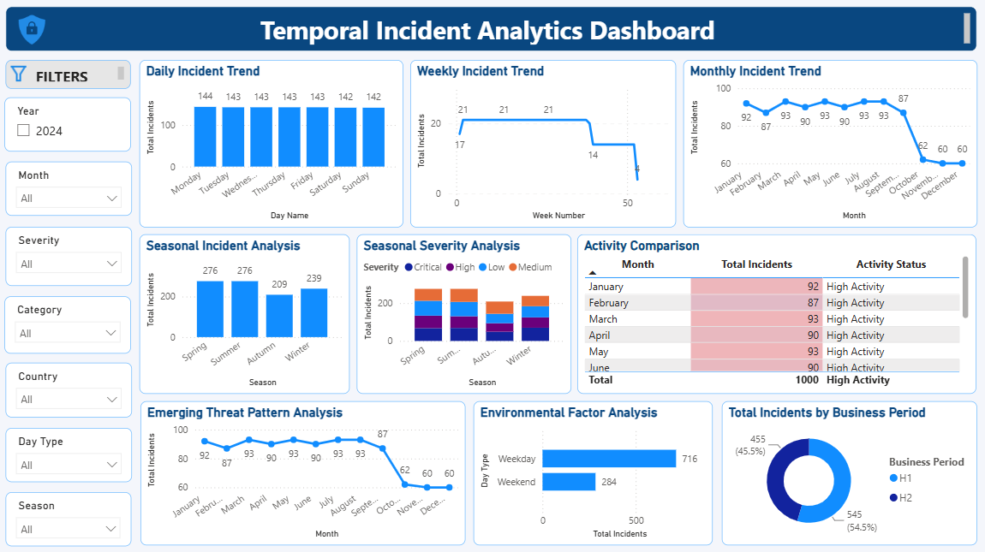
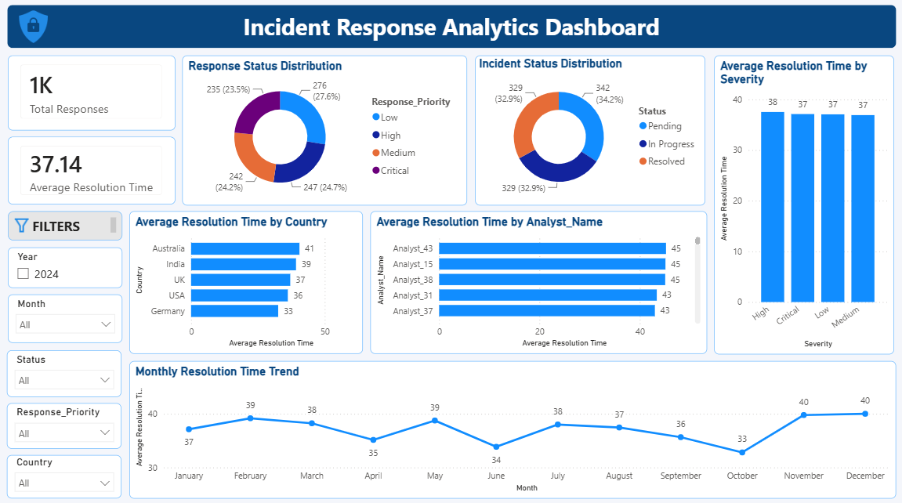
12.2 Temporal Analysis
Incident patterns were analyzed at multiple time levels:
- Hourly
- Daily
- Weekly
- Monthly
This allows users to identify when incident activity is higher or lower.
12.3 Seasonal Analysis
The project analyzes changes in incident activity across different time periods.
This can help identify recurring patterns.
12.4 Anomaly and Spike Analysis
The dashboard helps identify unusual increases or decreases in incident activity.
These spikes can be useful for security monitoring because sudden changes may require further investigation.
12.5 Environmental Factor Analysis
Environmental or supporting factors were analyzed where required.
This helps explore whether environmental conditions are associated with changes in cybersecurity incidents.
12.6 Emerging Threat Patterns
The dashboard identifies threat categories that show important changes or patterns.
This helps security teams monitor emerging threats.
12.7 Response and Resolution Analysis
Incident response was analyzed using:
- Response time
- Resolution time
- Incident status
- Open incidents
- Closed incidents
This provides an operational view of incident management.
12.8 Open vs Closed Incidents
The dashboard compares open and closed incidents.
This helps users understand the current workload and resolution status.
12.9 Response by Team/City/Severity
Response performance was compared across:
- Operational units
- Locations
- Severity levels
This helps identify areas where response performance may require improvement.
12.10 Slicers
The milestone includes filters such as:
- Year
- Month
- Severity
- Category
- City
- Environmental Factor
These allow users to explore temporal and response patterns interactively.
12.11 Milestone 3 Outcome
Milestone 3 provides a deeper understanding of:
- When incidents occur
- How incident activity changes
- Possible spikes
- Emerging threat patterns
- Response performance
- Resolution performance
- Current open/closed workload

13. MILESTONE 4 – SECURITY RISK ASSESSMENT AND PREDICTIVE INTELLIGENCE
Milestone 4 represents the final analytical stage of the project.
It combines security risk assessment, predictive intelligence and executive analytics.
13.1 SECURITY RISK ASSESSMENT
The purpose of this dashboard is to understand the current security risk and vulnerability.
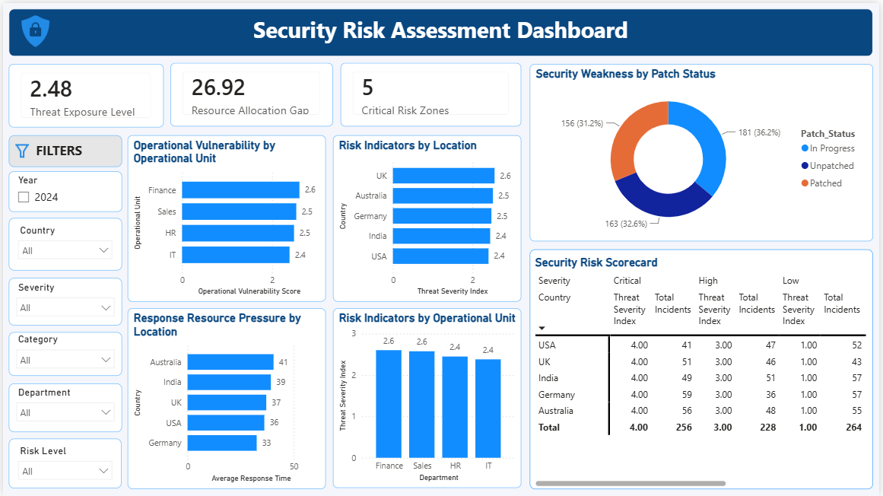
Threat Exposure Level
The Threat Exposure Level provides an overall indicator of security exposure.
It helps users understand the current level of threat affecting the organization.
Resource Allocation Gap
The Resource Allocation Gap indicates the identified gap in resources required to handle security risks.
This can support decisions about resource prioritization.
Critical Risk Zones
Critical Risk Zones identify areas requiring greater security attention.
This helps security teams focus on the most important risk areas.
Operational Vulnerability
Operational vulnerability is compared across operational units.
This helps identify departments or units with comparatively higher vulnerability.
Risk Indicators by Location
Risk indicators are compared across locations.
This helps identify geographical areas with relatively higher risk.
Security Weakness by Patch Status
Patch status is analyzed using categories such as:
- Patched
- Unpatched
- In Progress
This helps identify assets that may require additional security attention.
Response Resource Pressure
Response pressure is analyzed across locations.
Locations with higher response times may require further investigation into response processes and resource availability.
Security Risk Scorecard
The Security Risk Scorecard provides a detailed comparison of risk information by country and severity.
It allows users to examine:
- Critical incidents
- High incidents
- Low incidents
- Threat Severity Index
- Total incidents

13.2 PREDICTIVE INTELLIGENCE
The Predictive Intelligence dashboard focuses on possible future security risks.
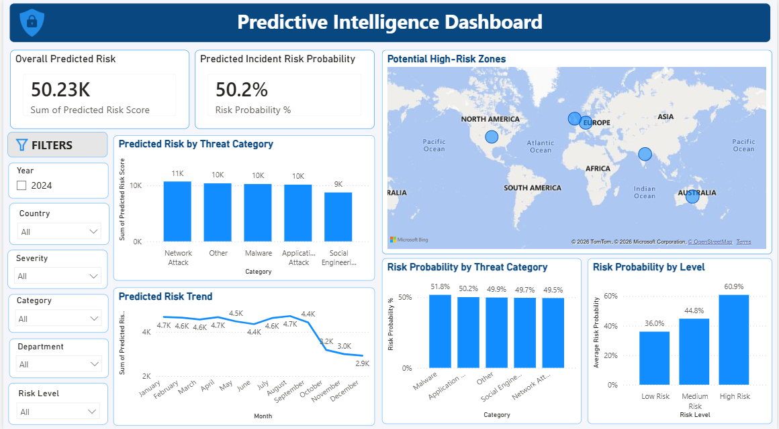
Overall Predicted Risk
This KPI represents the overall predicted risk generated from the project analysis.
It provides a high-level view of predicted security exposure.
Predicted Incident Risk Probability
This indicator shows the predicted probability associated with incident risk.
It helps users understand the likelihood level represented by the analysis.
Predicted Risk by Threat Category
Predicted risk is compared across threat categories.
This helps identify categories that contribute more strongly to the predicted risk.
Predicted Risk Trend
The predicted risk trend shows how predicted risk changes over time.
This helps identify whether predicted risk is increasing or decreasing across the analyzed periods.
Potential High-Risk Zones
A geographical visual is used to identify potential high-risk zones.
This helps security teams understand where future risk may be concentrated.
Risk Probability by Threat Category
Risk probability is compared across different threat categories.
This provides a category-level view of predicted incident risk.
Risk Probability by Level
Risk probability is compared across:
- Low Risk
- Medium Risk
- High Risk
This helps users understand how predicted probability differs across risk levels.
13.3 MODEL PERFORMANCE EVALUATION
The predictive analysis should be interpreted as an analytical/predictive indicator based on the available project data.
Where applicable, prediction-related measures and probability outputs are used to compare risk categories, locations and trends.
The results are intended to support risk awareness and decision-making rather than replace a production cybersecurity detection system.
14. EXECUTIVE INTELLIGENCE DASHBOARD
The Executive Intelligence Dashboard provides a high-level summary for management.
It focuses on the most important strategic indicators.
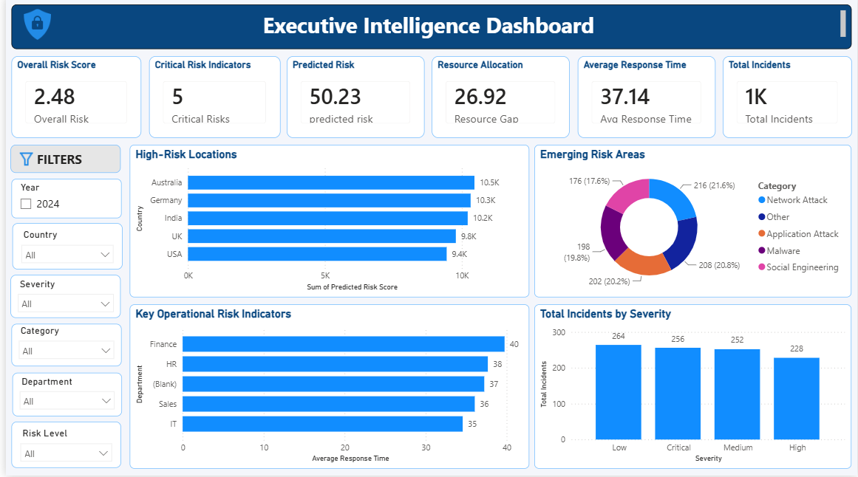
Overall Risk Score
The Overall Risk Score provides a summarized view of the organization's security risk.
Critical Risk Indicators
This KPI highlights the number of critical risk areas requiring attention.
Predicted Risk
The predicted risk KPI provides an executive-level view of future risk.
Resource Allocation
This indicator highlights the resource-related risk or gap identified by the analysis.
Average Response Time
This KPI provides an overview of the average incident response performance.
Total Incidents
This KPI shows the overall incident volume.
High-Risk Locations
The dashboard compares locations based on predicted risk.
This helps management identify geographical areas requiring additional attention.
Emerging Risk Areas
The emerging risk visual summarizes important threat categories.
This helps management understand which areas may require closer monitoring.
Key Operational Risk Indicators
Operational risk indicators are compared across departments.
Response time is one of the important indicators used to identify areas that may need operational improvement.
Total Incidents by Severity
This visual compares incidents across:
- Low
- Medium
- High
- Critical
This gives management a quick understanding of incident severity distribution.
15. DASHBOARD INTERACTIVITY
Interactive features were used throughout the project to make the dashboards easier to explore.
Depending on the milestone, slicers include:
- Date/Year
- Month
- Country/City/Location
- Severity
- Category
- Department/Operational Unit
- Risk Level
- Environmental Factor
Other interactive features include:
- Drill-through
- Tooltips
- Dynamic titles
- Interactive maps
- Cross-filtering between visuals
These features allow users to analyze the data according to their specific requirements.
16. KEY PROJECT INSIGHTS
The complete project provides several important types of insights.
Insight 1 – Threat Severity
Cybersecurity incidents differ significantly in their severity.
Separating incidents into Low, Medium, High and Critical categories helps prioritize security response.
Insight 2 – Geographical Risk
Risk and incident activity vary across locations.
Geographical analysis helps identify locations that require greater monitoring.
Insight 3 – Operational Vulnerability
Risk indicators differ across operational units.
This can help management identify departments that may require additional security attention.
Insight 4 – Response Performance
Response and resolution times vary across locations and operational units.
Higher response times may indicate areas where response processes or resources need improvement.
Insight 5 – Patch and Security Weakness
Patch status provides an important indication of potential security weakness.
Unpatched or incomplete patching status should receive appropriate attention.
Insight 6 – Temporal Patterns
Incident activity changes over time.
Trend and spike analysis helps identify periods that may require increased monitoring.
Insight 7 – Emerging Threats
Threat categories can show different levels of activity and predicted risk.
Monitoring emerging categories can help security teams prepare for potential changes.
Insight 8 – Predicted Risk
Predictive analysis provides an additional view of possible future security risk.
This can support proactive security planning.
Insight 9 – High-Risk Zones
Combining geographical and predictive analysis helps identify potential high-risk locations.
Insight 10 – Executive Decision Support
The executive dashboard brings together the most important indicators into one summarized view.
17. STRATEGIC RECOMMENDATIONS
Based on the project analysis, the following recommendations can be considered.
Recommendation 1 – Prioritize High-Risk Locations
Locations showing higher risk indicators or predicted risk should receive increased monitoring and appropriate security resources.
Recommendation 2 – Improve Response Performance
Locations or operational units showing higher response times should be reviewed to identify process or resource-related issues.
Recommendation 3 – Strengthen Patch Management
Unpatched and incomplete patching should be monitored regularly to reduce potential security weaknesses.
Recommendation 4 – Monitor Emerging Threat Categories
Threat categories showing higher activity or predicted risk should be continuously monitored.
Recommendation 5 – Use Risk Indicators for Resource Planning
Risk scores and operational indicators can be used to support security resource allocation.
Recommendation 6 – Monitor Trends Continuously
Incident and predicted-risk trends should be monitored regularly to identify sudden changes or emerging patterns.

18. LIMITATIONS
The project has some limitations.
- The analysis depends on the quality and completeness of the available datasets.
- Missing or incomplete information can affect analytical results.
- Predictive outputs should be treated as analytical indicators rather than guaranteed future events.
- A production cybersecurity environment would require real-time security data and more advanced machine-learning models.
- Risk scores depend on the measures and assumptions defined within the project.
- External cybersecurity intelligence sources were not fully integrated into the dashboard.
19. FUTURE SCOPE
The project can be extended in the future by:
- Integrating real-time cybersecurity feeds
- Using advanced machine-learning models
- Adding automated anomaly detection
- Adding real-time alerts
- Integrating SIEM systems
- Adding more detailed asset-level risk scoring
- Improving prediction accuracy using larger datasets
- Adding automated risk notifications
- Integrating additional environmental and external threat intelligence
- Developing automated security recommendations
A future version could also provide real-time monitoring instead of relying mainly on historical datasets.
20. CONCLUSION
The Infosys Cyber Threat Analytics Platform with Incident Visualization System provides a structured approach to cybersecurity data analysis.
The project was developed through four milestones.
Milestone 1 established the foundation by analyzing threat classification, incident severity, response indicators and basic geographical information.
Milestone 2 added geographical intelligence and helped identify threat concentration and high-risk locations.
Milestone 3 introduced temporal analysis and incident response analytics, allowing users to understand trends, patterns, spikes and response performance.
Milestone 4 extended the solution into security risk assessment, predictive intelligence and executive analytics.
The final dashboards provide different levels of information:
Historical and Incident Analysis → Current Risk Assessment → Predictive Intelligence → Executive Decision Support
The solution demonstrates how Power BI can transform cybersecurity datasets into interactive and meaningful analytical dashboards.
Overall, the project helps users understand cybersecurity incidents, identify important risk areas, evaluate operational performance, monitor potential future risks and support better security-related decisions.
FINAL PROJECT FLOW
The complete project can be summarized as:
DATA COLLECTION
↓
DATA CLEANING & TRANSFORMATION
↓
DATA MODELING
↓
MILESTONE 1 – THREAT & SEVERITY ANALYSIS
↓
MILESTONE 2 – GEOSPATIAL INTELLIGENCE
↓
MILESTONE 3 – TEMPORAL & INCIDENT RESPONSE ANALYTICS
↓
MILESTONE 4 – SECURITY RISK & PREDICTIVE INTELLIGENCE
↓
EXECUTIVE INTELLIGENCE
↓
STRATEGIC DECISION SUPPORT

